THE TRAGEDY OF FLIGHT- A COMPREHENSIVE CRASH ANALYSIS

1. *Introduction:* **“Sometimes bad luck hits you like in an ancient Greek tragedy, and it’s not your own making. When you have a plane crash it is not your fault”**
   1. Overview:

Loss of control typically occurs when pilots fail to recognize and correct a potentially dangerous situation, causing an aircraft to enter an unstable condition. Such incidents are typically triggered by unexpected, unusual events-often comprising multiple conditions that rarely occur together-that fall outside of the normal repertoire of pilot experience.

For example*,* This might be a combination of unusual meteorological conditional, ambiguous readings or behaviour from the technology, and pilot in experience-any one or two of which might be okay, but altogether they can overwhelm a crew. Safety scientists describe this as the “SWISS CHEESE” model of failure, when the holes in organizational defences line up in ways that had not been foreseen. These incident require rapid interpretation and responses, and it is here that things can go wrong.

* 1. Purpose:

Most accident occur during the takeoff, climb, descent, and landing phase of a flight so flying nonstop would reduce exposure to these most accident prone phases of flight. Currently, Aircraft with more then 30 passenger seats were all designed and certificated under the strictest regulations. Also, in the unlikely event of a serious accident, larger air craft provide a better opportunity for a passenger survival.

Although the information seems repetitious, the locations of the closet emergency exists may be different depending on the aircraft that you fly on and seat you are in. Overhead storage bins may be not be able to hold very heavy objects during turbulence, so if you or another passenger trouble lifting an article into the bin, have it stored elsewhere. Keeping the belt on when you are seated provides that extra protection you might need if the plane hits unexpected turbulence. The primary reason flight attendants are on an aircrafts is for safety, so if one of them asks you to do something like fasten your seat belts, do it first and ask questions later.

1. Problems Definition and Design Thinking:

2.1) Empathy Map:

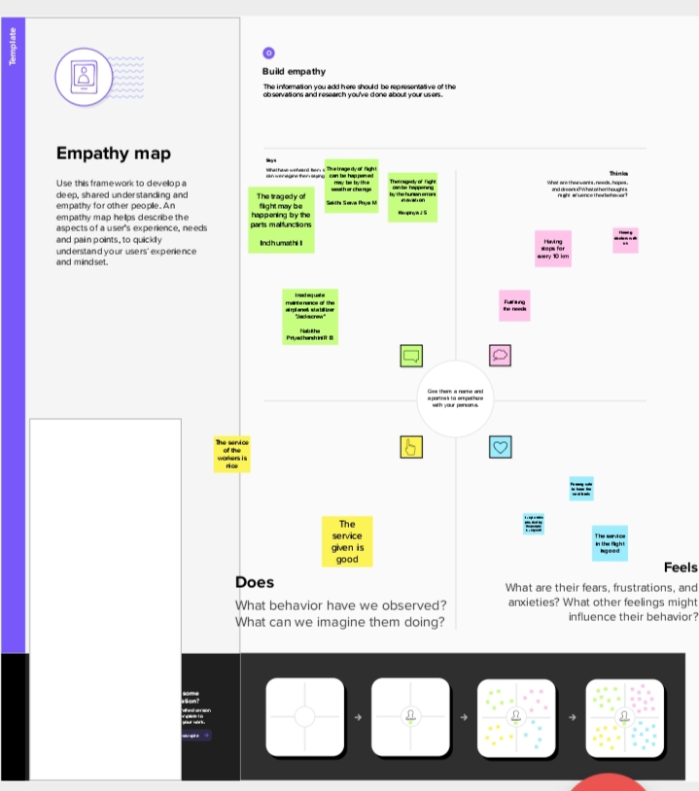

2.2) Ideation and Brainstorming Map:

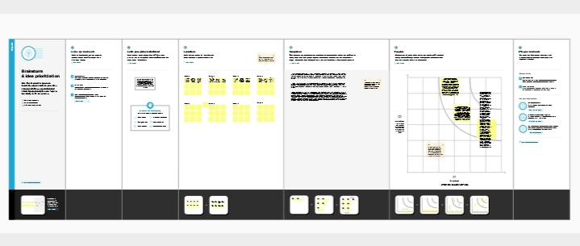

1. Resulting:

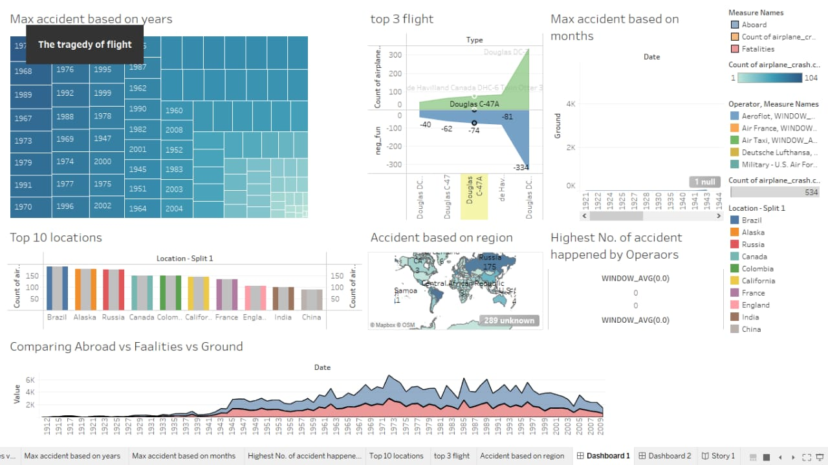

1. Advantages and Disadvantages:

Advantages:

* Fast speed of transport
* Low infrastructure required to establish this services.
* No physical barriers can affect its speed.
* Aviation is very important in defence service to protect any nation.
* It provides as safe and secure environment to travel by valuable goods.
* Good facilities at most airports; refreshments/meals en route.
* Minimal check-in time for most domestic (within the UK ) flights.

Disadvantages:

* Costlier than other modes.
* Limited capacity of people or goods can move.
* Undependable and risky since it depends on weather conditions.
* Unfit for cheap bulky goods since travel costs can be higher than the goods cost.
* Airports can often be several miles from city centre.
* Need to pay extra if your luggage is above the weight limit.
* Parking can be expensive if leaving car at the airport for more than just one day.

1. Applications:

The airline with the least amount of crashes is air Premia from south Korea. They have had zero crashes, zero accidents, and even zero incidents. Nothing wrong has ever happened onboard an premia plane.

Qantas has never lost a jet due to a crash, but they have had some big incidents before like QF1,QF30, and QF72. They again, Qantas has also been around for more than 100 years. They have had far more successful flights than Air premia. We can’t base an airline’s safety purely off how many crashes they’ve had. America Airlines has had many crashes, but are still an incredibly safe airline. Conversely, many south-East Asian airlines (I won’t name them out of respect) have had few crashes, but are quite unsafe due to industry standards in the area.

1. Conclusion:

* Comparing Aboard vs Fatalities vs Ground.
* Max accidents based on years.
* Accidents happened in 1972 (MAX ACCIDENTS) based on months.
* Highest No. of accident happened by Operators.
* Top 10 locations which had more accidents.
* Top 3 flights which have max accident history.
* Accident based on regions.

1. Future Scope:

Albeit most forecasts are based on predictive modeling and probability of identified outcome’s many fail to realize the anticipated. Notwithstanding this, most reputable organizations devoutly dwell on research and planning for the future . Therein lies innovation and growth that the future portends. In this paper, NASA, Airbus and Boeing are primarily selected for the study of their published game changing keystone projects for the future. The raison d’etre of growth in aviation is its increasingly positive correlation with economy and socio-political integration . Policy guidelines for education to cater for the future needs of the dynamic aviation industry is also deliberated.